C#.NET
Overview
- It’s a programming language, offered by .NET Framework.
- It is recommended for both .NET programming beginners and .NET professionals.
- This is the mostly used languages used by most of the IT companies today.
- It derives some programming features from “C” and “C++” also.
- It is the object oriented programming language.
- The programmer, having knowledge in C and C++ can easily understand the programming in C#.

File Extensions in C#
- Project File Extension: “.csproj” (means C Sharp Project)
- Code File Extension: “.cs” (means C Sharp)

Sample Application Development in C#
- Launch Visual Studio 2008.
- Create a new “Console Application” with “Visual C#” language.
- It generates an empty “Program” class, with “Main()” method.
- Type a simple program as follows:

Application 1: A simple C# program

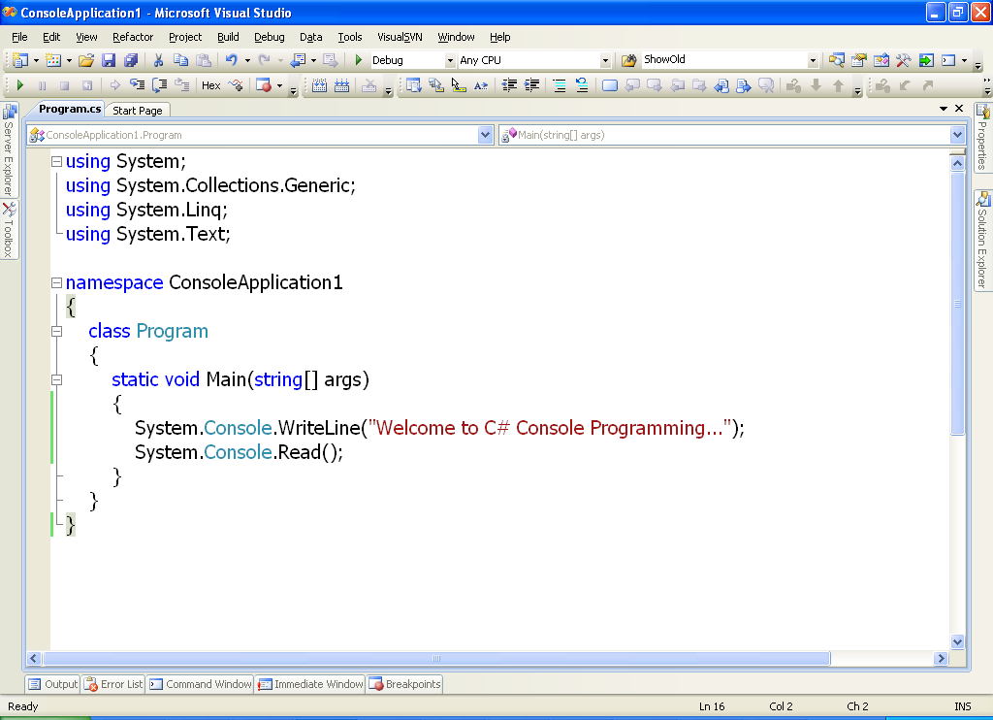
- To run the application, simply press “F5” key on the keyboard. Then the application will be executed and output will be as follows.

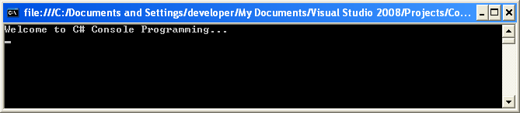

A closer look at the syntax
Importing section
Namespace Declaration
Class Declaration

Main() method

1. Importing section:
- This section contains importing statements that are used to import (include or link) the .NET Framework Class Library (FCL).
- This is most similar to the “include” statements in “C” language.
- Syn:
using namespace;
- Note: If the required namespace is a member of another namespace, we have specify the parent and child namespaces separated with “.” (dot).
- Ex:
using System;
using System.IO;
using System.Data;
etc.

2. Namespace declaration:
- Here, a user define namespace is to be declared.
- Rule: In .NET applications, all the classes related to the project should be declared in one namespace.
Syn:
namespace namespacename
{

}
- Generally, the namespace name will be same as “Project” name.

2. Class declaration:
- This is to declare the startup class of the project.
- In every .NET application (like Console and Windows Application), there should a startup class. In these applications, the startup class name should be “Program”. You can’t change it.
- A startup class nothing but a class, which contains Main() method.
Syn:
class classname
{

}

3. Main() method:
- As you know already in C/C++ languages, the Main() method is the Starting Execution Point of the application.
- When the application is executed, the Main() method will be executed first.
- This method contains the main logic of the application.
Syn:
Specifies that Main() is a static method; to enable JIT, to directly call Main() method directly, without creating an instance of “Program” class.
Means no return value

Receives arguments sent to the Main() method in a string array format.
